**Array Declarations , Constructions , Initialization**

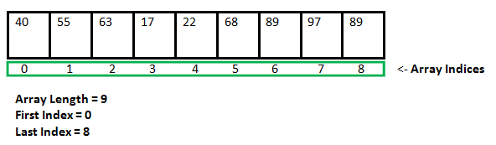

type var-name[];

OR

type[] var-name;

**Example:**

// both are valid declarations

int intArray[];

or int[] intArray;

byte byteArray[];

short shortsArray[];

boolean booleanArray[];

long longArray[];

float floatArray[];

double doubleArray[];

char charArray[];

// an array of references to objects of

// the class MyClass (a class created by

// user)

MyClass myClassArray[];

Object[] ao, // array of Object

Collection[] ca; // array of Collection

// of unknown type

**Instantiating an Array in Java**

var-name = new type [size];

**Example:**

int intArray[]; //declaring array

intArray = new int[20]; // allocating memory to array

OR

int[] intArray = new int[20]; // combining both statements in one

**// Java program to illustrate creating an array**

// of integers, puts some values in the array,

// and prints each value to standard output.

class GFG

{

public static void main (String[] args)

{

// declares an Array of integers.

int[] arr;

// allocating memory for 5 integers.

arr = new int[5];

// initialize the first elements of the array

arr[0] = 10;

// initialize the second elements of the array

arr[1] = 20;

//so on...

arr[2] = 30;

arr[3] = 40;

arr[4] = 50;

// accessing the elements of the specified array

for (int i = 0; i < arr.length; i++)

System.out.println("Element at index " + i +

" : "+ arr[i]);

}

}

Output:

Element at index 0 : 10

Element at index 1 : 20

Element at index 2 : 30

Element at index 3 : 40

Element at index 4 : 50

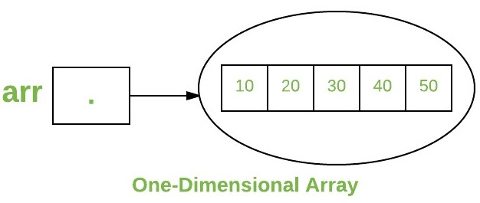

// Java program to illustrate creating an array of

// objects

class Student

{

public int roll_no;

public String name;

Student(int roll_no, String name)

{

this.roll_no = roll_no;

this.name = name;

}

}

**// Elements of the array are objects of a class Student.**

public class GFG

{

public static void main (String[] args)

{

// declares an Array of integers.

Student[] arr;

// allocating memory for 5 objects of type Student.

arr = new Student[5];

// initialize the first elements of the array

arr[0] = new Student(1,"aman");

// initialize the second elements of the array

arr[1] = new Student(2,"vaibhav");

// so on...

arr[2] = new Student(3,"shikar");

arr[3] = new Student(4,"dharmesh");

arr[4] = new Student(5,"mohit");

// accessing the elements of the specified array

for (int i = 0; i < arr.length; i++)

System.out.println("Element at " + i + " : " +

arr[i].roll_no +" "+ arr[i].name);

}

}

Output:

Element at 0 : 1 aman

Element at 1 : 2 vaibhav

Element at 2 : 3 shikar

Element at 3 : 4 dharmesh

Element at 4 : 5 mohit

**MCQ’s**

**1) An Array in Java is a collection of elements of ___ data type.**

A) Same

B) Different

C) -

D) -

Answer [=]

**A**

**2) The Java Virtual Machine (JVM) implements arrays as ___ type.**

A) Primitive

B) Object

C) -

D) -

Answer [=]

**B**

**Explanation:**

**That is the reason why Java Array has predefined methods.**

**3) Unlike C-Arrays, the Java-Arrays have ___.**

A) Names

B) Values

C) Methods and Fields

D) None

Answer [=]

**C**

**4) An array declaration in Java without initialization ___ memory.**

A) Does not allocate

B) Allocates memory

C) -

D) -

Answer [=]

**A**

**Explanation:**

**Only initialization causes memory to be allocated.**

**5) In Java language, an array index starts with ___.**

A) -1

B) 0

C) 1

D) Any integer

Answer [=]

**B**

**6) Which are the special symbols used to declare an array in Java?**

A) Braces { }

B) Parentheses ()

C) Square Brackets [ ]

D) Angled Brackets < >

Answer [=]

**C**

**7) Which are the special symbols used to initialize an array at the time of the declaration itself?**

A) Parentheses ( )

B) Square Brackets [ ]

C) Braces { }

D) Angled Brackets < >

Answer [=]

**C**

**Explanation:**

**int[] nums = {1,3,6};**

**8) It is possible to skip initializing some elements of the array during Shorthand Initialization. (TRUE / FALSE)**

A) FALSE

B) TRUE

C) -

D) -

Answer [=]

**A**

**Explanation:**

**No, you can not skip any elements. All elements need to be initialized in one go or at the same time.**

**9) In Java, an array can be declared without initialization without mentioning the size. (TRUE / FALSE)**

A) TRUE

B) FALSE

C) -

D) -

Answer [=]

**A**

**Explanation:**

**It is a Lazy initialization of an array.**

**10) What is the output of the below Java code snippet with arrays?**

**static int[] nums;**

**public static void main(String args[])**

**{**

**System.out.println(nums.length);**

**}**

A) 0

B) null

C) Compiler error

D) Runtime Exception - Null Pointer Exception

Answer [=]

**D**